ASSIGNMENT 27

Name : Akanksha Joshi

Roll No : B038

Batch : 3

Div : BTech CS B

--------------------------------------------------------------------------------------------------------------------------

Using functions, re-write and execute Python program to :

Q1. Add natural numbers upto n where n is taken as an input from user.

Source Code

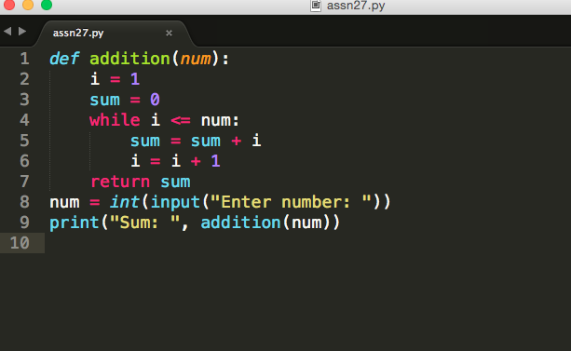

Output

Enter number: 15

Sum: 120

Q2.Print Fibonacci series till nth term (Take input from user)

Source Code

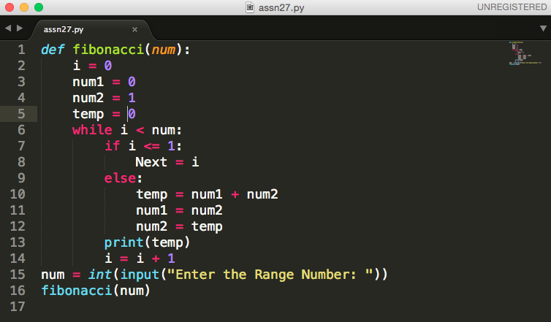

Output

Enter the Range Number: 20

0

0

1

2

3

5

8

13

21

34

55

89

144

233

377

610

987

1597

2584

4181